**JAVASCRIPT PRACTICALS**

**A1. Write a JavaScript program to calculate area of triangle, area of rectangle and area of circle.**

<!DOCTYPE html>

<html lang="en">

<head>

    <meta charset="UTF-8">

    <meta name="viewport" content="width=device-width, initial-scale=1.0">

    <title>Document</title>

</head>

<body>

    <list>

        <button onclick="area_triangle()" id="btnl1"> triangle</button>

        <button onclick="area_circle()" id="btnl2"> area_circle</button>

        <button onclick="area_rectangle()" id="btnl3"> rectangle</button>

    </list>

    <script>

        function area_triangle() {

            var side1 = parseInt(prompt("Enter side1 in cm "));

            var side2 = parseInt(prompt("Enter side2 in cm "));

            var side3 = parseInt(prompt("Enter side3 in cm "));

            var s = (side1 + side2 + side3) / 2;

            var area = Math.sqrt((s*(s - side1) * (s - side2) * (s - side3)));

            console.log( "area of triangle is=" + area.toFixed(2) + "sq.cm ");

            document.write("<br>area of triangle is =" + area.toFixed(2) + "sq.cm ");

        }

        function area_rectangle() {

            var side1 = parseInt(prompt("Enter side1"));

            var side2 = parseInt(prompt("Enter side2"));

            var area = side1 * side2;

            console.log("<br>" + "area of rectangle is " + area.toFixed(2) + "sq.cm");

            document.write("<br>" + "area of rectangle is =" + area.toFixed(2) + "sq.cm");

        }

        function area_circle() {

            var radius = parseInt(prompt("Entr the radius in cm"))

            var ar = 3.14 * radius * radius;

            console.log("<br>" + "Area of Circle is=" + ar.toFixed(2) + "")

            document.write("<br>" + "Area of Circle is=" + ar.toFixed(2) + "")

        }

    </script>

</body>

</html>

**Output:--**

FIRST VIEW

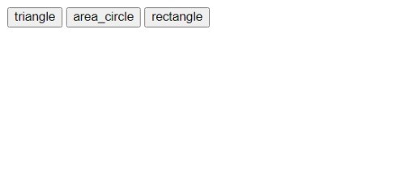

After clicking for input

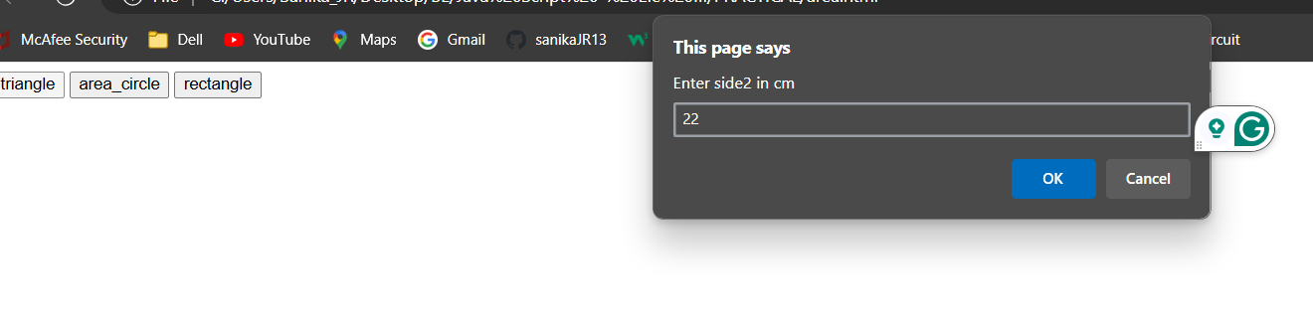

After finding area--

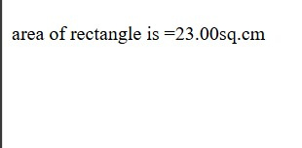

**A2. Write a JavaScript program to generate the multiplication table of a given number.**

<html>

<head>

<title>  Multiplication table</title>

<h3> Multiplication Table and Testing NaN</h3>

<p> Please perform testing NaN first </p>

<button onclick="tNaN()" id = "btnl">Test NaN</button>

<BR></BR>

<input id ="text" placeholder = "Enter Number">

<button onclick="mtable()" id = "btnl">Generate Multiplication Table</button>

<script>

function tNaN(){

// The parseInt method parses a value as a string and returns the first integer.

const n1 = parseInt(prompt("Enter an integer to test"));

const s1 = prompt("Enter a character string to test");

const n2 = n1/0;

console.log("n1/0 is " + n2);

const n3 = -n1/0;

console.log("-n1/0 is" + n3);

const n4 = s1/2;

console.log("s1/2 is " +n4);

}

//function mtable(){

var num = parseInt(document.getElementById("text").value);

//creating a multiplication table

for(let i = 1; i <= 10; i++) {

    // multiply i with number

    const result = i * num;

    // display the result

    console.log("<br>" + num + " " + "*" + " " + i + " " + "=" + " " + result);

    document.write( "<br>" + num + " " + "*" + " " + i + " " + "=" + " " + result);

}

}

</script>

</head>

</html>

**OutPut:-**

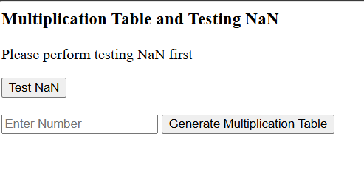

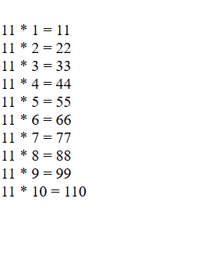

**A3. Write a JavaScript program to following operations on a given string, • Reverse string • Replace characters of a string. • String is Palindrome.**

1. **Prog to replace a character of a string**

<!DOCTYPE html>

<html>

<head>

<meta charset="UTF-8" />

<title>program to replace only a character of a string</title>

</head>

<body>

<script>

//Replace first occurance

const string = prompt('Enter a string: ');

// replace the characters

const newText = string.replace('r', 'b');

console.log(newText);

document.write(newText+"<br>");

//Replace charcter

const regex = /r/g;

const newText1 = string.replace(regex, 'b');

// display the result

console.log(newText1);

document.write(newText1);

</script>

</body>

</html>

**Output:-**

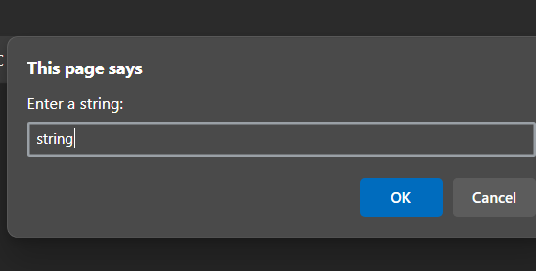

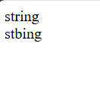

**2) Reverse a string using for loop**

<!DOCTYPE html>

<html>

<head>

<h1>Program to reverse a string using for loop</h1>

</head>

<body>

<script>

function reverseString(str) {

// empty string

let newString = "";

for (let i = str.length - 1; i >= 0; i--) {

newString += str[i];

}

return newString;

}

// take input from the user

const string = prompt('Enter a string: ');

const result = reverseString(string);

document.write(result);

</script>

</body>

</html>

**Output:-**

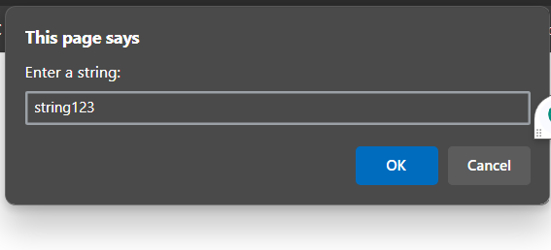

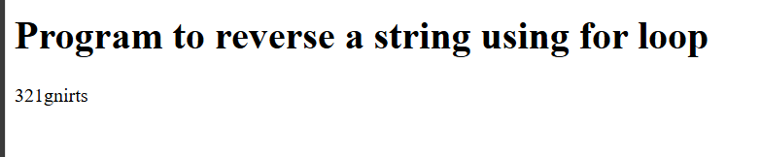

1. **Reverse a string using built-in method**

<!DOCTYPE html>

<html>

<head>

<meta charset="UTF-8" />

<title>program to reverse a string using built-in method</title>

</head>

<body>

<script>

function reverseString(str) {

// return a new array of strings

const arrayStrings = str.split("");

// reverse the new created array elements

const reverseArray = arrayStrings.reverse();

// join all elements of the array into a string

const joinArray = reverseArray.join("");

// return the reversed string

return joinArray;

}

// take input from the user

const string = prompt('Enter a string: ');

const result = reverseString(string);

console.log(result);

document.write(result);

</script>

</body>

</html>

**Output:-**

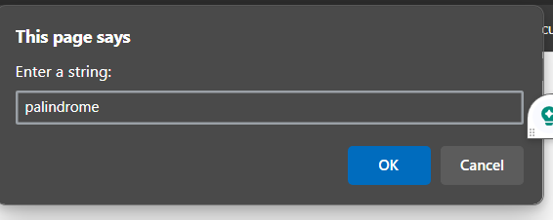

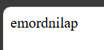

1. **Palindrome using built-in method**

<!DOCTYPE html>

<html>

<head>

<meta charset="UTF-8" />

<title>Palindrome</title>

/*1. Get the strings or numbers from the user.

2. Take a temporary variable that holds the numbers.

3. Reverse the given number.

4. Compare the original number with the reversed number

5. If the temporary and original number are same, it the number or string is a Palindrome.

6. Else the given string or number is not the Palindrome.*/

</head>

<body>

<scrip>

//Palindrome using inbuilt function

const string1= prompt('Enter a string or number: ');

function palindromeFun (str )

{

// convert the string into an array using the string.split() function

const arrValue = string1.split ('');

// use reverse() method to reverse the array values

const reveArrVal = arrValue.reverse();

// use join() method to group the array values into the string

const revString = reveArrVal.join('');

if (string1 == revString) // if string condition is equal to the revString

{

alert('It is a Palindrome string '); // print the Palindrome

}

else {

alert (' It is not a Palindrome string' ); // if the condition is not true.

} }

const value = palindromeFun(string1);

console.log(value);

</script>

</body>

</html>

**Output:-**

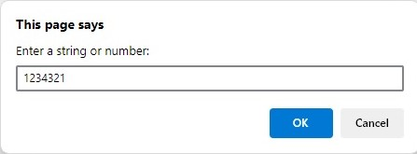

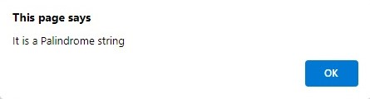

1. **Palindrome using CSS**

<!DOCTYPE html>

<html>

<head>

<title> Palindrome Program in JavaScript </title>

<style>

h1 {

text-align: center;

padding: 30px;

background-color: blue;

color: white;

}

.palin {

margin: 30px;

width: 80%;

border: 3px solid rgb(138, 9, 9);

border-radius: 5px;

padding: 30px;

}

#pa2 {

width: 50%;

border: 3px solid orangered;

border-radius: 5px;

padding: 10px;

}

</style>

</head>

<body>

<h1> Palindrome Program in JavaScript </h1>

<div class="palin">

<label> Enter any string or number : </label>

<input id= "pa"> <br> <br>

<label> Resultant string : </label>

<input id = "pa2" > </b> <br>

<input type= "submit" onclick = "palindrome()" > <br>

</div>

<script type = "text/javascript">

function palindrome()

{

var a= document.getElementById("pa").value;

// get the total length of the words

var b="";

// Use for loop to divide the words into 2 half

for (let i = a.length-1; i >=0; i--) {

b+=a[i];

}

// validate the first and last characters are same

if (a==b)

document.getElementById("pa2"). value = b + " is a Palindrome String ";

else

document.getElementById("pa2"). value = b + " is not a Palindrome String";

}

</script>

</body>

</html>

Output:-

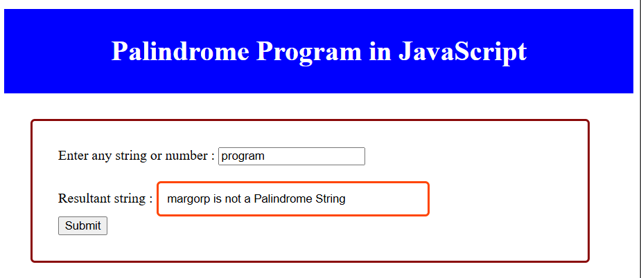

1. **Program to reverse, replace a character of a string and check whether entered string is Palindrome in JavaScript**

<!DOCTYPE html>

<html>

<head>

<title> program to reverse,replace a character of a string and check whether entered string is Palindrome in JavaScript </title>

<style>

    h1 {

    text-align: center;

    padding: 100px;

    background-color: blue;

    color: white;

    }

    .palin {

    margin: 30px;

    width: 80%;

    border: 3px solid rgb(138, 9, 9);

    border-radius: 5px;

    padding: 50px;

   }

    #pa2 {

    width: 50%;

    border: 3px solid orangered;

    border-radius: 5px;

    padding: 5px;

   }

    #ra {

    width: 50%;

    border: 3px solid orangered;

    border-radius: 5px;

    padding: 5px;

    }

    #rc {

    width: 50%;

    border: 3px solid orangered;

    border-radius: 5px;

    padding: 5px;

    }

    </style>

</head>

<body>

        <h1> Program to reverse,replace a character of a string and check whether entered string is Palindrome in JavaScript  </h1>

        <div class="palin">

        <label> Enter any string or number : </label>

        <input id= "pa"> <br> <br>

        <label> Reverse of a string : </label>

        <input id= "ra"> <br> <br>

        <label> Replace charcter r with b : </label>

        <input id= "rc"> <br> <br>

        <label> Resultant string : </label>

         <input id = "pa2" > </b> <br>

         <button onclick= "reverseString();replacestring();palindrome();" >Submit</button> <br>

        </div>

        <script type = "text/javascript">

        function reverseString()

        {

            var a= document.getElementById("pa").value;

            var newString = "";

                for (let i = a.length - 1; i >= 0; i--)

                    {

                    newString += a[i];

                    }

                document.getElementById("ra"). value = newString + " ";

        }

        function replacestring()

        {

            var a= document.getElementById("pa").value;

            const regex = /r/g;

            var newText1 = a.replace(regex, 'b');

            document.getElementById("rc"). value = newText1 + " ";

        }

        function palindrome()

        {

        var a= document.getElementById("pa").value;

          // get the total length of the words

        var b="";

            // Use for loop to divide the words into 2 half

            for (let i = a.length-1; i >=0; i--)

            {

                b+=a[i];

            }

        // validate the first and last characters are same

        if (a==b)

        document.getElementById("pa2"). value = b + " is a Palindrome String ";

        else

        document.getElementById("pa2"). value = b + " is not a Palindrome String";

        }

        </script>

        </body>

        </html>

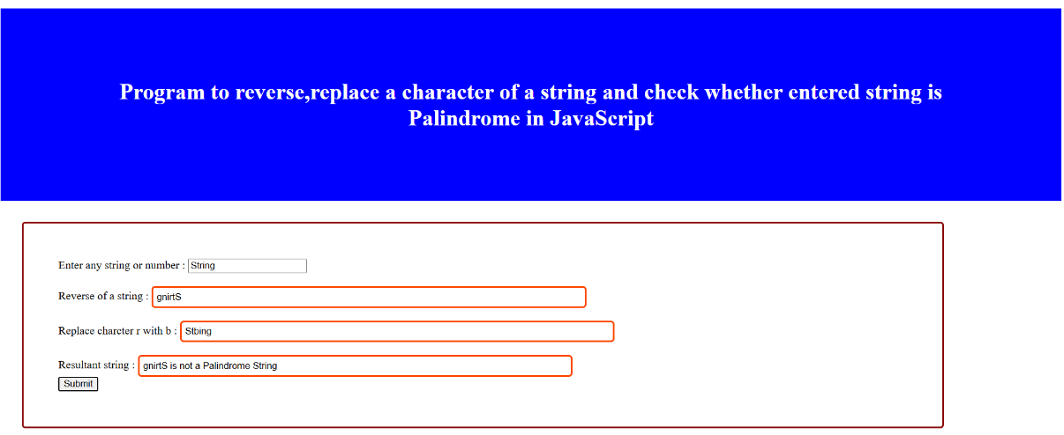

**A4. Write a JavaScript program to compare two strings using various methods.**

Using uppercase

<!DOCTYPE html>

<html>

<head>

<title>method1 is string compare using upper case</title>

</head>

<body>

<script>

const string1 ='JavaScript Program';

const string2 ='javascript pragram';

//compare both strings

const result =string1.toUpperCase()===string2.toUpperCase();

if(result)

{

console.log("The strings are equal");

document.write("The string are equal");

}

else

{

console.log("The strings are not equal");

document.write("The string are not equal");

}

</script>

</body>

</html>

**OUTPUT :**

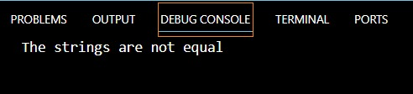



2) Using regex

<!DOCTYPE html>

<html>

<head>

<title>compare string using regex</title>

</head>

<body>

<script>

const string1 ='JavaScript Program';

const string2 ='javascript program';

//create regex

const pattern =new RegExp(string1,"gi");

//compare the strings

const result =pattern.test(string2);

if(result)

{

console.log("strings are equal");

document.write("strings are equal");

}

else

{

console.log("The strings are not equal");

document.write("strings are not equal");

}

</script>

</body>

</html>

**OUTPUT :**

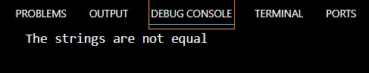



3) Using localeCompare

<!DOCTYPE html>

<html>

<head>

<title>method3 using localeCompare</title>

</head>

<body>

<script>

const string1 ='JavaScript Program';

const string2 ='javascript program';

//to compare

const result =string1.localeCompare(string2);

if(result==0)

{

console.log("strings are equal");

document.write("strings are equal");

}

else

{

console.log("The strings are not equal");

document.write("strings are not equal");

}

</script>

</body>

</html>

**OUTPUT :**

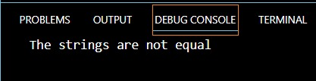



**A5. Write a JavaScript program that will create a countdown timer.**

<!DOCTYPE html>

<html>

<head>

<!-- Display the countdown timer in an element -->

<h3> Building Coundown Timer Using Date Function </h3>

</head>

<body>

<p id="demo"></p>

<script>

// Set the date we're counting down to

var tDate = new Date();

var month = tDate.getMonth() + 1; // Add 1 to get the correct month (1-12)

var day = tDate.getDate(); // Use getDate() to get the day of the month (1-31)

document.write("<BR>" + "Todays Date is " + tDate);

document.write("<BR>" + "Month is " + month);

document.write("<BR>" + "Day is " + day);

document.write("<BR>" + "Time is " + tDate.getTime() + "msec");

var t = tDate.getTime();

var countDownDate = new Date("Aug 17, 2024 10:58:25").getTime();

var diff = countDownDate - t;

document.write("<BR>" + "Time in msec from 1 Jan 1970 till Jan 5, 2024 is "+ countDownDate);

//JavaScript stores dates as number of milliseconds since January 01, 1970. Zero time is January 01, 1970 00:00:00 UTC.

document.write("<BR>" + "Difference " + diff);

// Update the count down every 1 second

var x = setInterval(function(){

// Get today's date and time

var now = new Date().getTime();

// Find the distance between now and the count down date

var dit = countDownDate - now;

// Time calculations for days, hours, minutes and seconds

var days = Math.floor(dit / (1000 * 60 * 60 * 24));

var hours = Math.floor((dit % (1000 * 60 * 60 * 24)) / (1000 * 60 * 60));

var minutes = Math.floor((dit % (1000 * 60 * 60)) / (1000 * 60));

var seconds = Math.floor((dit % (1000 * 60)) / 1000);

// Display the result in the element with id="demo"

document.getElementById("demo").innerHTML = days + "d " + hours + "h "

+ minutes + "m " + seconds + "s ";

// If the count down is finished, write some text

if (dit < 0) {

clearInterval(x);

document.getElementById("demo").innerHTML = "EXPIRED";

}

}, 1000);

</script>

</body>

</html>

**Output :**

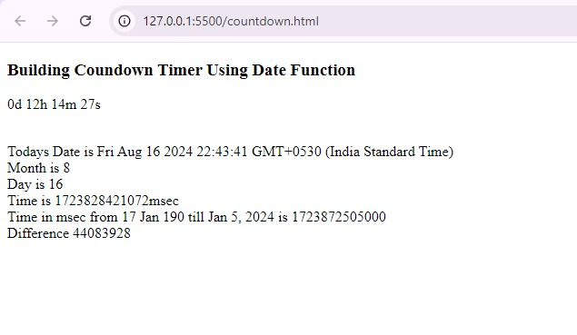

**B1. Manipulation of an array**

**Write a JavaScript program that will create an array and perform following operations,**

* **To remove specific element from the array.**
* **Check if the array contains a specified value.**
* **To empty an array**

# <!DOCTYPE html>

# <html lang="en">

# <head>

# <title>Array Operations</title>

# </head>

# <body>

# <h1>Javascript Practical of Array manipulation</h1>

# <script>

# var array = [];

# var x = prompt("Enter the size of array");

# //Input the elements in the array

# for (i=0;i<x;i++)

# {

# array[i] = prompt('Enter array Element ' + (i+1)); }

# //Display the array elements

# document.write("Array entered is" +"</br> </br>");

# for (i=0;i<x;i++)

# {

# 

# document.write("The element at position " + (i) + " is : " + array[i] + "</br> </br>");

# }

# //A. Remove element from array

# function removeElement(removeEle)

# { var removeEle = prompt('Enter array Element to delete ' );

# for (i=0;i<x;i++)

# { if(array[i]== removeEle)

# {

# // array.remove(i);

# document.write("After deleting array element:  "+ array[i] + "   array is"+"</br> </br>");

# delete array[i];

# }

# }

# }

# //B. Check for a specific value

# function searchElement(searchEle)

# {

# var searchEle = prompt('Enter array Element to find ' );

# let pres=false;

# pres=  array.includes(searchEle);

# if(pres == true)

# {

# document.write("Element " + searchEle + " is present in the array</br></br>");

# }

# else

# document.write("Element " + searchEle + "  is not present in the array</br></br>");

# }

# //searchElement(searchEle);

# //C. To empty an array

# function emptyArray()

# {

# array.splice(0,array.length);

# if(array.length == 0)

# {

# document.write("Array is empty now using splice method")

# }

# document.write(array); }

# removeElement();

# //Display the array elements

# for (i=0;i<x;i++)

# { document.write("The element at position " + (i) + " is : " + array[i] + "</br> </br>"); }

# searchElement();

# emptyArray() ;

# </script>

# </body>

# </html>

# OutPut:

# 

# 

# 

**B2. Appending Object to array and check if an object is an array**

**Write a JavaScript program that will append an object to an array and will check if an object is an array.**

<!DOCTYPE html>

<html lang="en">

<head>

<title>Append an Object to An Array</title>

</head>

<body>

<h1>JavaScript Program to Append an Object to An Array</h1>

<script>

var array = [];

var x = prompt("Enter the size of array");

//Input the elements in the array

for (i=0;i<x;i++)

{

array[i] = prompt('Enter array Element ' + (i+1));

}

//Display the array elements

for (i=0;i<x;i++)

{

document.write("The element at position " + (i) + " is : " + array[i] + "</br> </br>");

}

// program to append an object to an array using push() method

 function pushFunc(arr, obj)

{

// append object

arr.push(obj);

console.log(arr);

document.write("Using push method: "+arr + "</br></br>");

}

let obj1 = ["java","script"];

pushFunc(array, obj1);

// program to check if an object is an array

function checkObject(arr) {

// check if arr is array

const result = Array.isArray(arr);

if(result) {

console.log('[arr] is an array.');

 document.write("This is an array</br></br>");

}

else {

console.log('[arr] is not an array.');

document.write("This is not an array</br></br>");

}

}

checkObject(array);

console.log(array);

// program to append an object to an array using splice() method

function spliceFunc(arr, obj) {

   // find the last index

    let index = arr.length;

    // appending object to end of array

    arr.splice(1, 5, obj2);

    console.log(arr);

document.write("Splicing at index 2: "+arr + "</br></br>");

}

// object to add

let obj2 = ["We","like"];

// call the function

spliceFunc(array, obj2 );

// program to append an object to an array using unshift() method

function unshiftFunc(arr, obj) {

// append object

arr.unshift(obj);

console.log(arr);

document.write("Using unshift method: "+arr + "</br></br>");

}

let obj3 = ["We","learn","and"];

unshiftFunc(array, obj3);

// program to append an object to an array using Spread operator

function spreadOperator(arr, obj) {

   // append object

    arr = [...arr, obj4];

    console.log(arr);

document.write("Using spread operator: "+arr + "</br></br>");

}

// object to add

let obj4 =  ["Program","Ended"];

// call the function

spreadOperator(array, obj4);

</script>

</body>

</html>

**Output:**

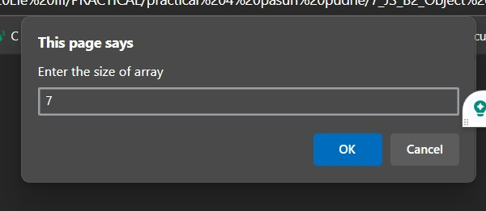

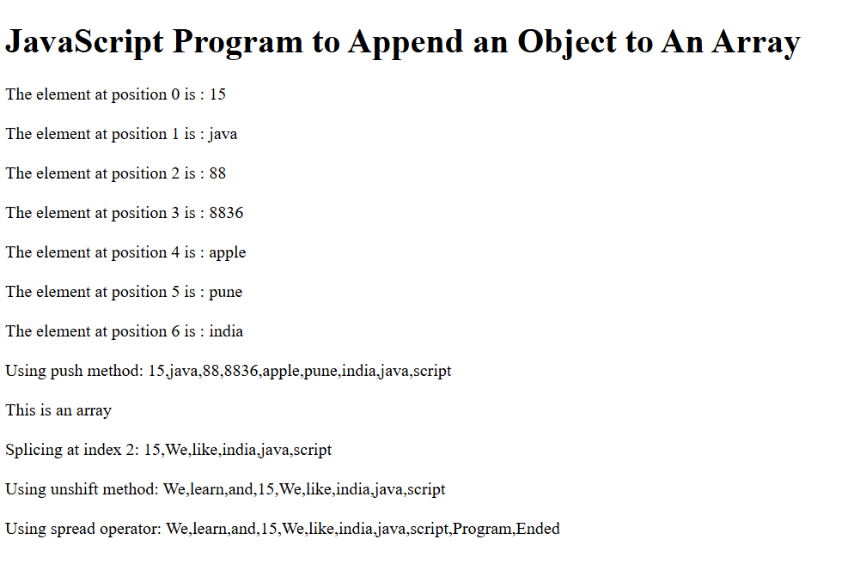

**B3. : Different Set Operations**

**Write a JavaScript program to illustrate different Set operations like:**

**\* Union**

**\* Intersection**

**\* Difference**

**\* Symmetric Difference**

<html>

<head>

<h2> Demonstrate Set Operations </h2>

<p> set A = ['apple', 'mango', 'orange'] </p>

<p> set B = ['grapes', 'apple', 'banana'] </p>

<p> set C = ['apple', 'orange'] </p>

<script>

// two sets of fruits

const setA = new Set(['apple', 'mango', 'orange']);

const setB = new Set(['grapes', 'apple', 'banana']);

const setC = new Set(['apple', 'orange']);

function union(a, b) {

    const unionSet = new Set(a);

    for (const i of b) {

        unionSet.add(i);

    }

return unionSet

}

const result1 = union(setA, setB);

console.log(result1);

document.write(result1);

function intersection(setA, setB) {

    const intersectionSet = new Set();

    for (let i of setB) {

        if (setA.has(i)) {

            intersectionSet.add(i);

        }

    }

return intersectionSet;

}

const result2 = intersection(setA, setB);

   console.log(result2);

   document.write(result2);

function difference(setA, setB) {

    let differenceSet = new Set(setA)

    for (let i of setB) {

        differenceSet.delete(i)

    }

 return differenceSet

}

const result3 = difference(setA, setB);

console.log(result3);

document.write(result3);

function subset(setA, setC) {

    for (let i of setC) {

        if (!setA.has(i)) {

            return false

        }

    }

    return true

}

const result = subset(setA, setC);

 console.log(result);

 document.write(result);

</script>

</head>

</html>

**Output:**

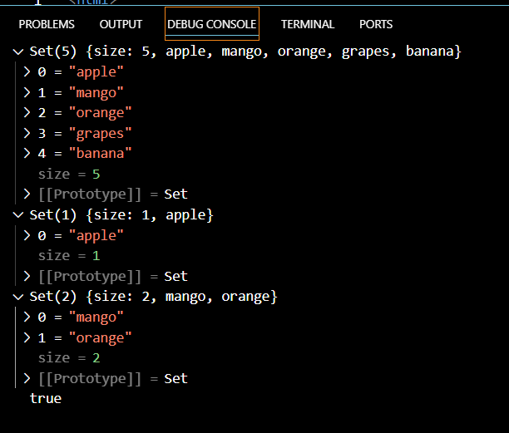

**C1. Write a JavaScript program to create a Home page of any website and change background color using**

* **On mouse over event**
* **On focus event**

<!DOCTYPE html>

<html>

<body>

<h2 align="center">A Home page of website that change background color using  •On mouse over event •On focus event</h2>

 <a onmouseover="document.body.style.backgroundColor ='#ADD8E6'"  style="margin:20px auto;

text-align:center;

display:block;

width:220px;"

class="button large hpbottom" >Hover over me to change the background color.</a><br>

  <a onmouseout="document.body.style.backgroundColor ='cyan'"style="margin:20px auto; text-align:center; display:block; width:220px;" class="button large hpbottom" >Hover out to change the background color.</a><br>

<h2 align="center">The focus Event</h2>

</body>

Enter your name: <input type="text" align="center" onfocus="myFunction(this)" onblur="blurFunction(this)" >

<script>

function myFunction(x) {

  x.style.background = "yellow";

}

function blurFunction(x) {

x.style.background  = "red";

}

</script>

</body>

</html>

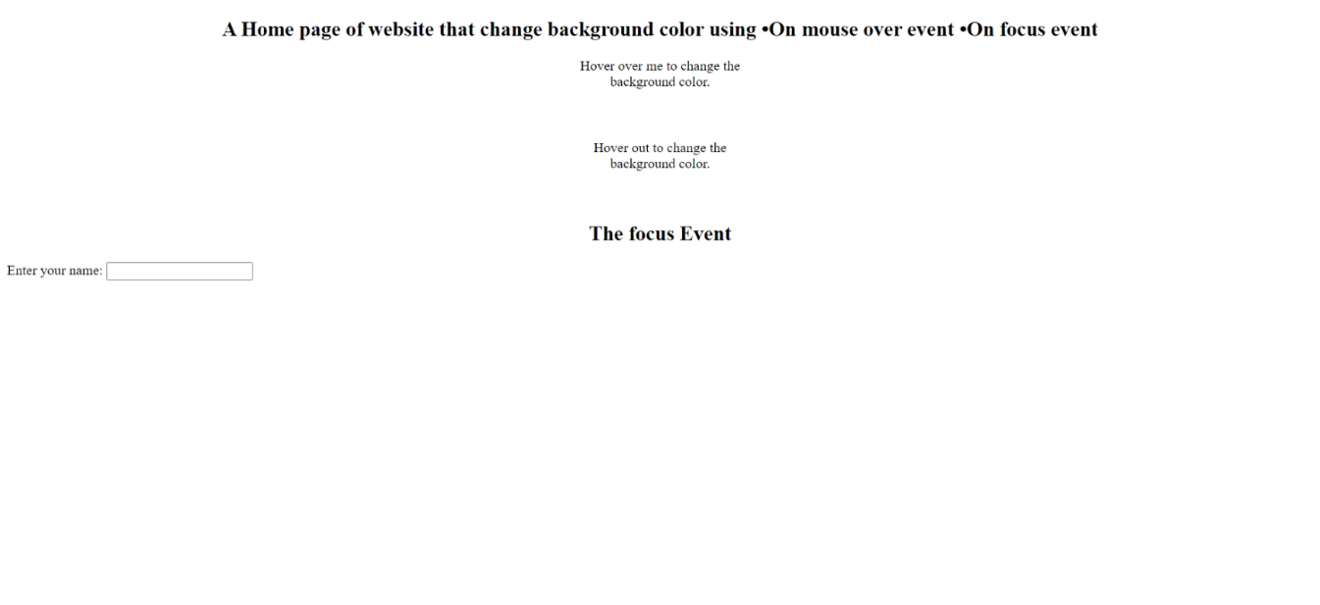

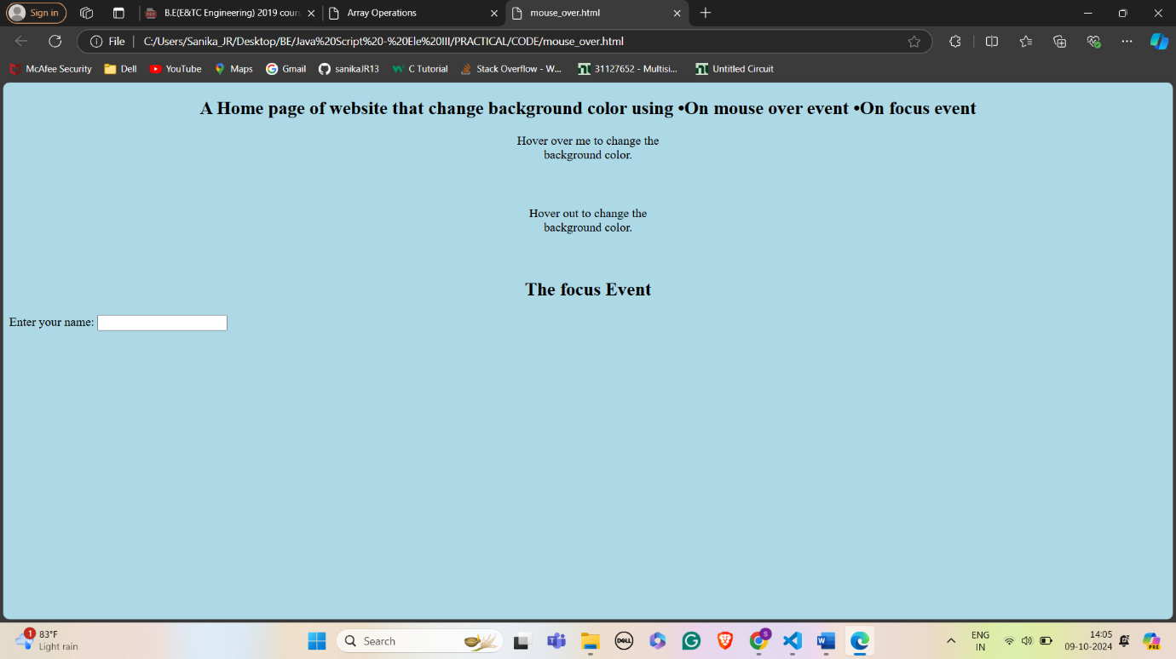

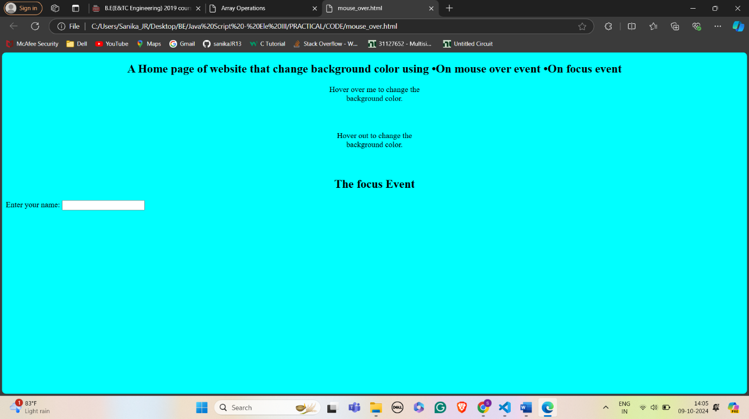

# 

# 

**C2. Create a student information Form to accept information like Name, Address, City, State Gender, Mobile Number, and email id. Perform validations for:**

* **Correct Names**
* **Mobile Names**
* **Email I.D.’s**
* **If no entered value**
* **Re-display for wrongly entered values with message**
* **Congratulation and Welcome page upon successful entries**

<!DOCTYPE html>

<html>

<head>

    <title>Student Information Form</title>

    <script>

        function validateForm() {

            var name = document.forms["myForm"]["name"].value;

            var address = document.forms["myForm"]["address"].value;

            var city = document.forms["myForm"]["city"].value;

            var state = document.forms["myForm"]["state"].value;

            var gender = document.forms["myForm"]["gender"].value;

            var mobile = document.forms["myForm"]["mobile"].value;

            var email = document.forms["myForm"]["email"].value;

            if (name == "" || address == "" || city == "" || state == "" || gender == "" || mobile == "" || email == "") {

                alert("Please fill out all fields.");

                return false;

            }

            var nameRegex = /^[A-Za-z\s]+$/;

            if (!name.match(nameRegex)) {

                alert("Invalid Name.");

                return false;

            }

            var mobileRegex = /^\d{10}$/;

            if (!mobile.match(mobileRegex)) {

                alert("Invalid Mobile Number.");

                return false;

            }

            var emailRegex = /^[a-zA-Z0-9._-]+@[a-zA-Z0-9.-]+\.[a-zA-Z]{2,4}$/;

            if (!email.match(emailRegex)) {

                alert("Invalid Email ID.");

                return false;

            }

            alert("Congratulation and Welcome!");

            return true;

        }

    </script>

</head>

<body>

    <form name="myForm" action="/submit_form" onsubmit="return validateForm()" method="post">

        <label for="name">Name:</label><br>

        <input type="text" id="name" name="name"><br>

        <label for="address">Address:</label><br>

        <input type="text" id="address" name="address"><br>

        <label for="city">City:</label><br>

        <input type="text" id="city" name="city"><br>

        <label for="state">State:</label><br>

        <input type="text" id="state" name="state"><br>

        <label for="gender">Gender:</label><br>

        <input type="text" id="gender" name="gender"><br>

        <label for="mobile">Mobile Number:</label><br>

        <input type="text" id="mobile" name="mobile"><br>

        <label for="email">Email ID:</label><br>

        <input type="text" id="email" name="email"><br>

        <input type="submit" value="Submit">

    </form>

</body>

</html>

**Output:**

